**Activity: Using the Play Axis visualization**

[Time series analysis](https://d3c33hcgiwev3.cloudfront.net/kenIGLrDSLSMNhGbhMkR2w_d12b0ce18a264b3e9ad61ab9eba410e1_Time-series-analysis.pbix?Expires=1712102400&Signature=be1pv8rsmVHy7I2J56DJO7yzjw3kmNXHBgricRKHQXm05u7~PEkOBM0ALcwI8l1AAaESQ2oS2T3fmaNoG9c~l6oDrgX-~Iy1cErPOleBfKaL8KXOkA~cQZNKi3G5ox3cBzkM25of4UFu1kK2DxrpdQgubEMa7YVlSdHcBCOOty0_&Key-Pair-Id=APKAJLTNE6QMUY6HBC5A" \t "_blank)

[PBIX File](https://d3c33hcgiwev3.cloudfront.net/kenIGLrDSLSMNhGbhMkR2w_d12b0ce18a264b3e9ad61ab9eba410e1_Time-series-analysis.pbix?Expires=1712102400&Signature=be1pv8rsmVHy7I2J56DJO7yzjw3kmNXHBgricRKHQXm05u7~PEkOBM0ALcwI8l1AAaESQ2oS2T3fmaNoG9c~l6oDrgX-~Iy1cErPOleBfKaL8KXOkA~cQZNKi3G5ox3cBzkM25of4UFu1kK2DxrpdQgubEMa7YVlSdHcBCOOty0_&Key-Pair-Id=APKAJLTNE6QMUY6HBC5A" \t "_blank)

**Introduction**

In this reading, you'll explore how to perform time series analysis in Microsoft Power BI, emphasizing the importance of suitable visualization types like line charts, area charts, and scatter charts.

Additionally, you'll delve into the use of the **Play Axis** visualization, available through Microsoft AppSource, to create compelling and dynamic representations of time trends and patterns in data.

**Scenario**

As Adventure Works' fiscal year-end approaches, the sales team shifts their focus towards evaluating year-long results. A decision is made to put together a report that highlights the team's achievements over the past year.

You take on the task of creating a time-series analysis report, delving into the sales data accumulated throughout the year. However, you decide to add a surprising twist - incorporating a **Play-axis** visual.

This dynamic feature not only enhances interactivity but also promises to grab everyone's attention and provide a unique perspective on the year's sales performance.

For this example, you are developing a sales report. You decide to use two visuals, a **Scatter chart** and **Line chart**, for the purpose of time series analysis and then enhance those visuals with animation so the sales team can see how the sales data changes over time.

**Instructions**

**Step 1: Add a Line chart visual to the report**

1. Download and open the *Times series analysis* PBIX file in Power BI Desktop.
2. Locate the **Visualizations** pane on the right of the Power BI interface.
3. Select the **Line chart** icon to add the chart to your report canvas.

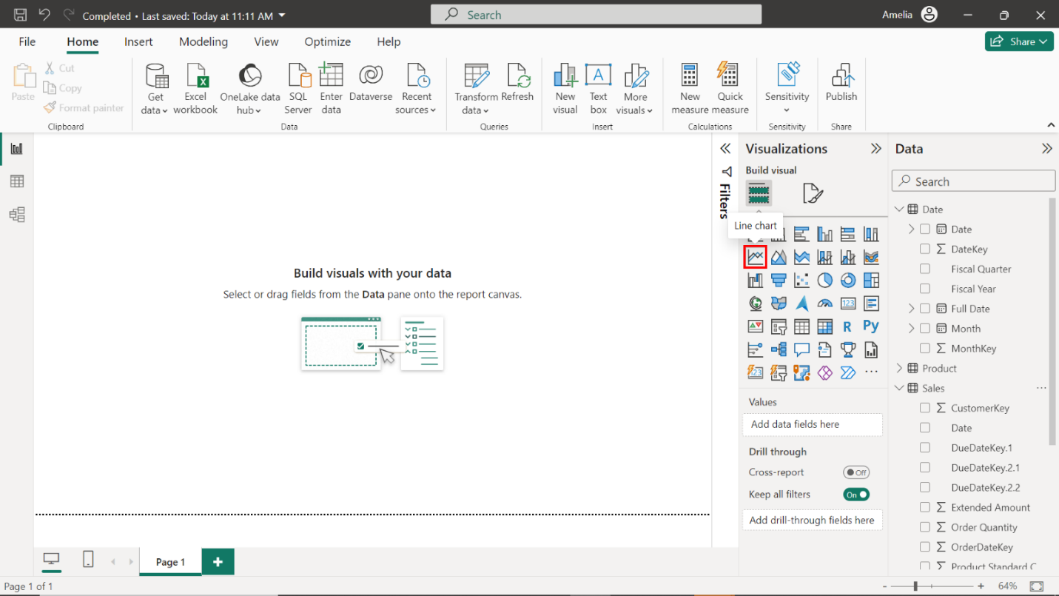

1. In the **Fields** pane, identify the **Sales Amount** field in the **Sales** table.
2. Drag **Sales Amount** into the **Y-Axis** well of the **Line chart**. The **Y-axis** on the **Line chart** updates with this information.

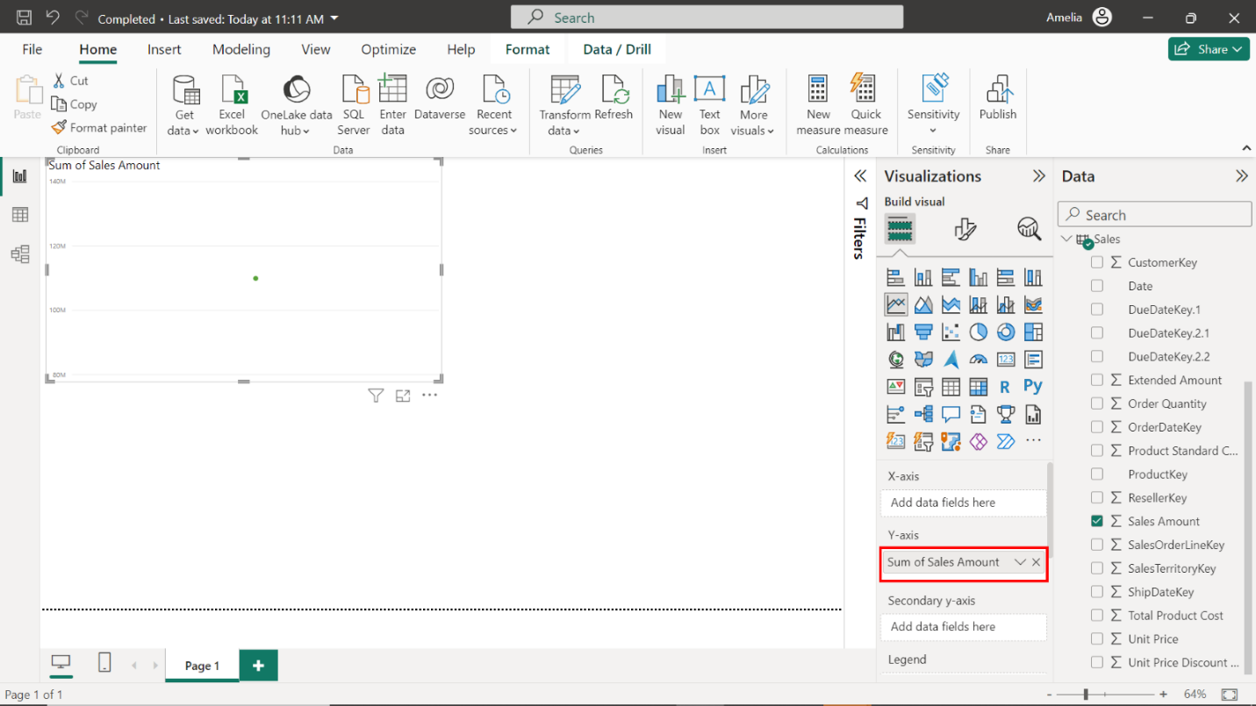

1. Next, locate and drag the **Date** field from the **Date** table into the **X-Axis** area of the **Line chart**. The date is now represented on the **X-axis**, allowing you to visualize how sales amounts have changed over time.

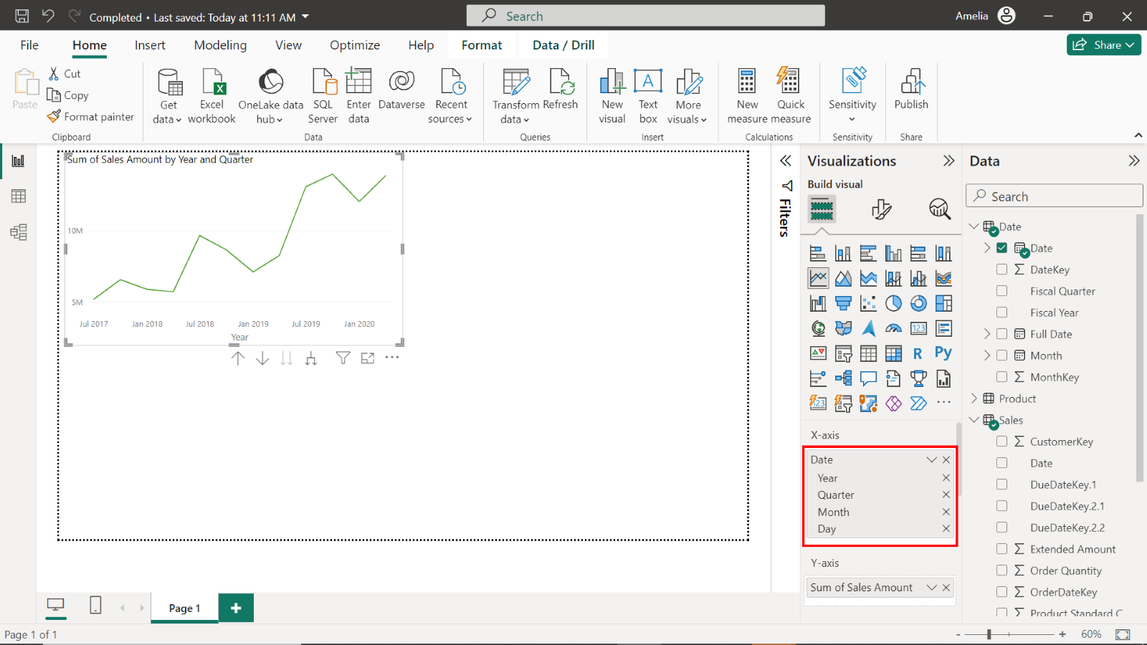

1. Finally, add **Category** from the **Product** table to the **Legend** area to break down sales by category over time.

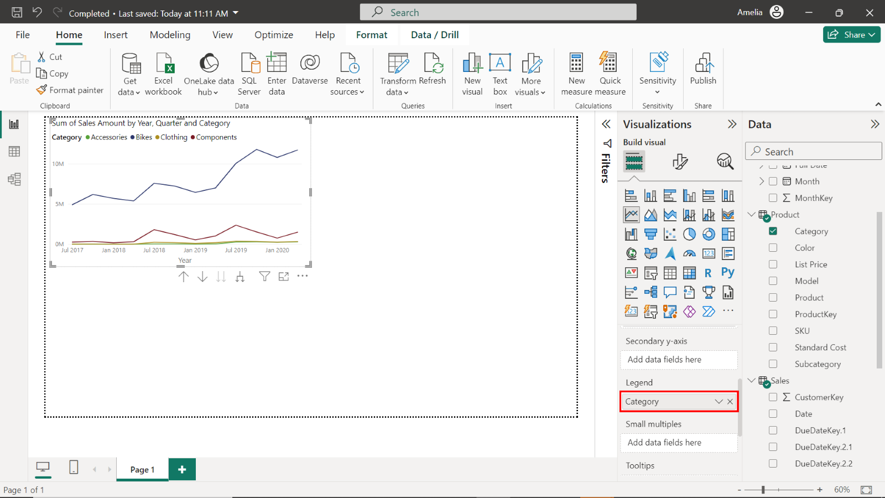

**Step 2: Add a Scatter chart visual to the report**

1. In the **Visualizations** pane, locate and select the **Scatter chart** icon.

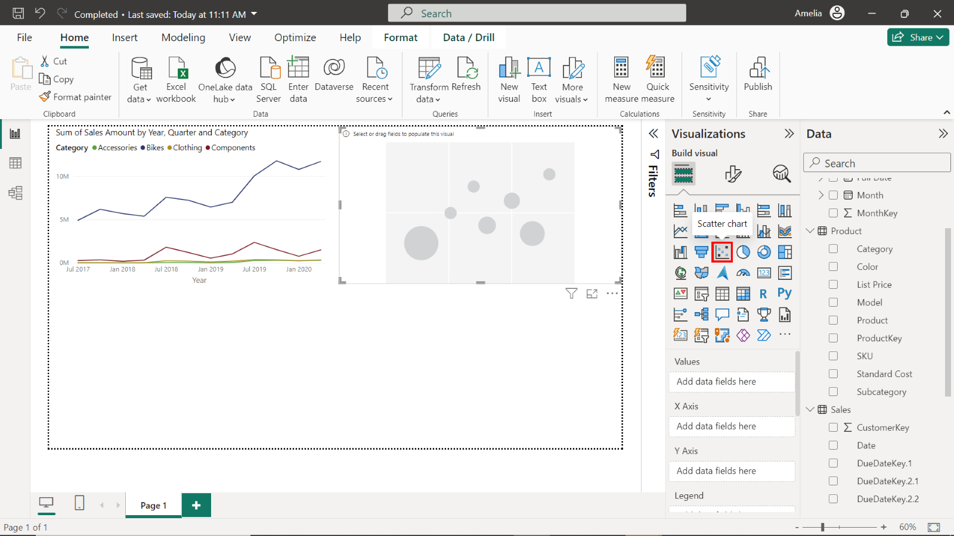

1. Drag **Order Quantity** from the **Sales** table into the **X-Axis** well to determine the value of each point in the **Scatter chart**.

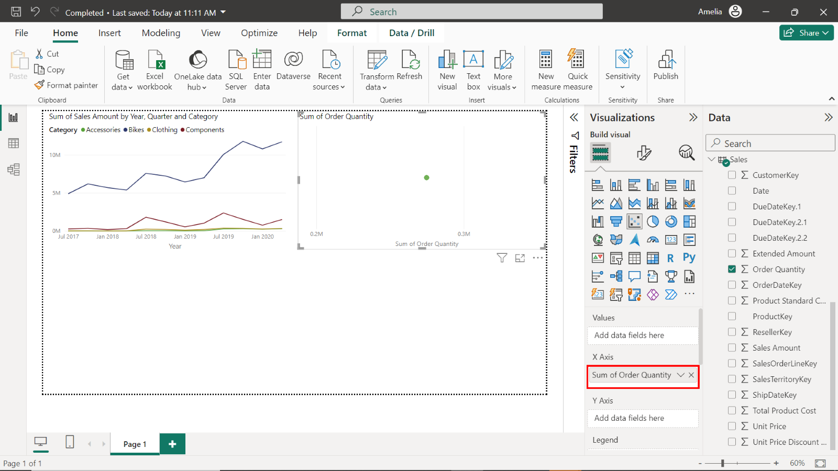

1. Drag the **Date** field from the **Date** table into the **Values** well. This sets the horizontal axis to represent time, showing how the **Order quantity** data points are distributed over this period.

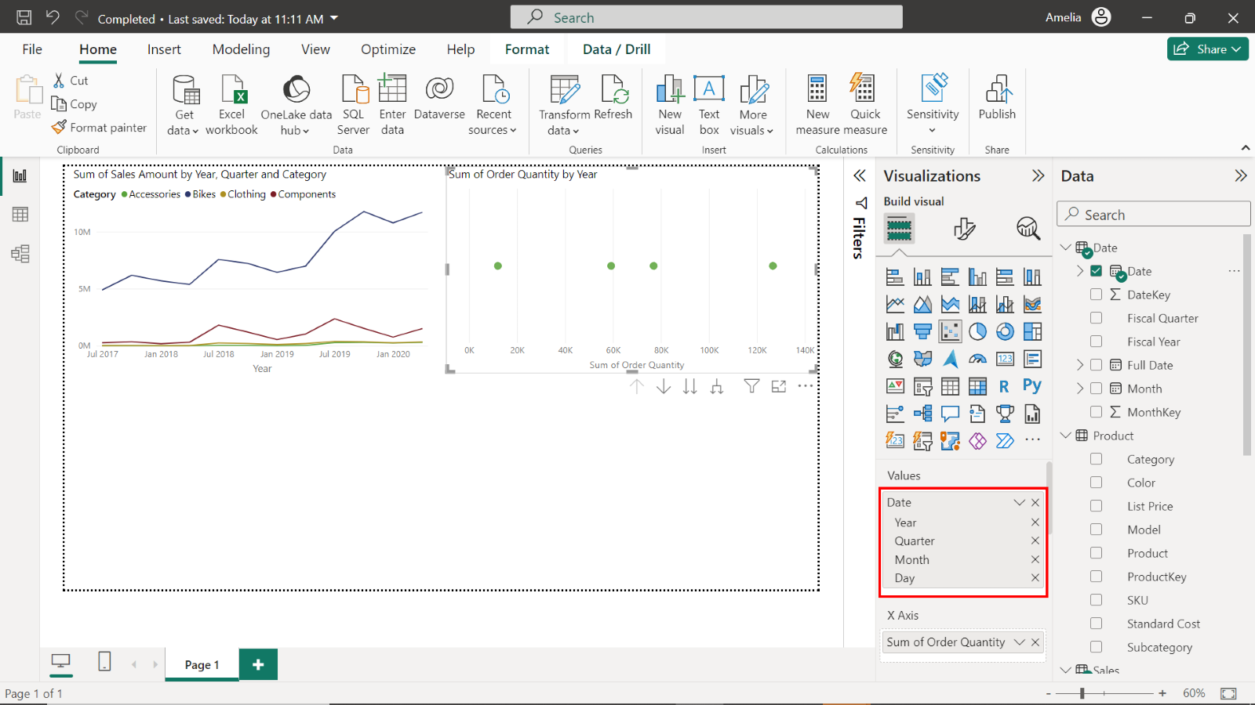

1. Finally, drag **Sales Amount** from the **Sales** table into the **Y-Axis** well.

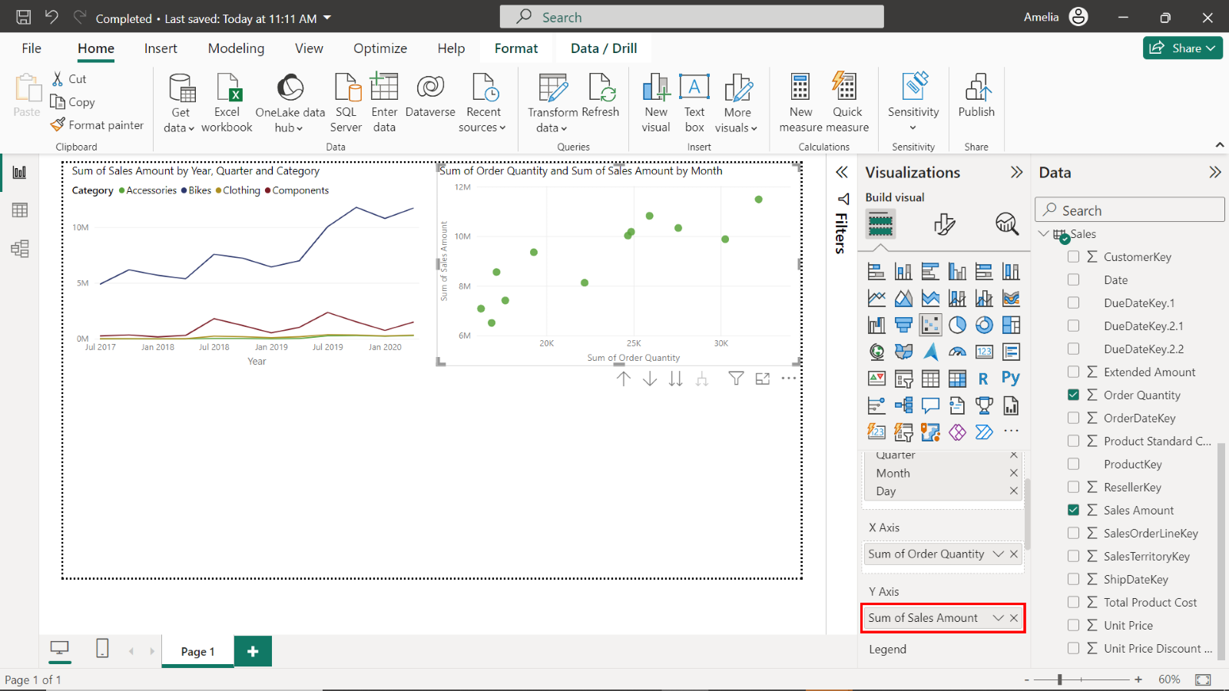

**Step 3: Import the animation custom visual**

1. In the **Visualizations** pane, select the ellipses (...) which represent the **Get more visuals** choice. Selecting the ellipses will allow you to explore additional visuals that are not included by default in Power BI.

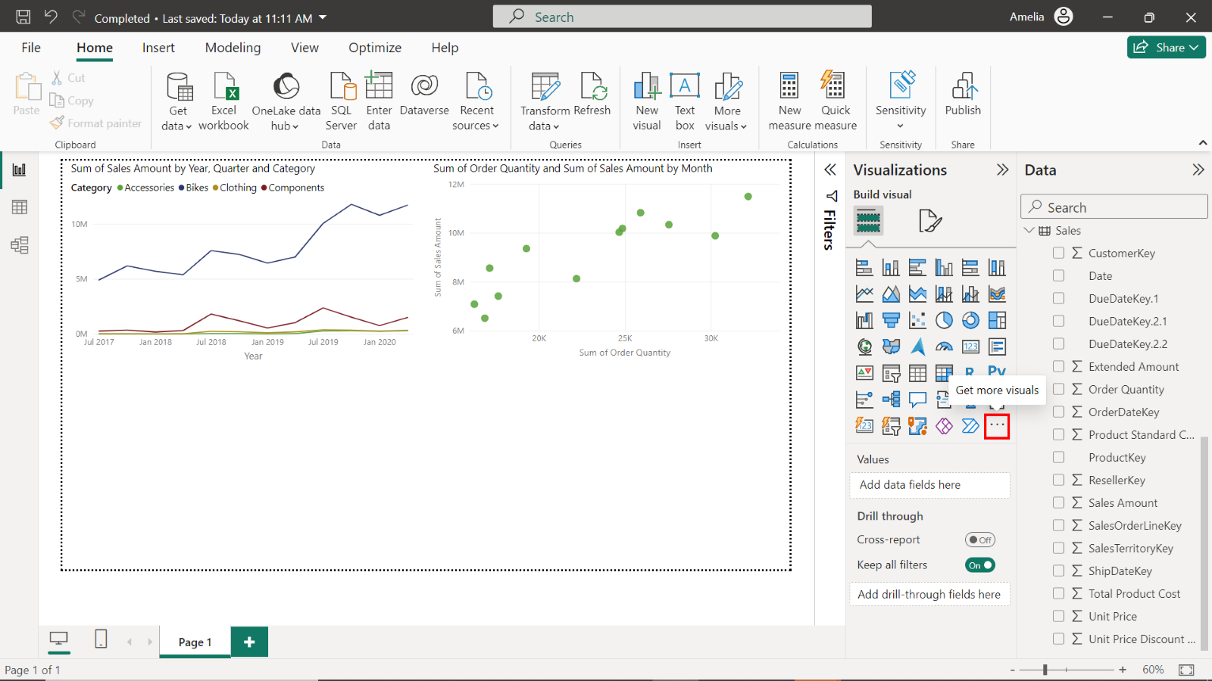

1. A **Power BI visuals** window opens with a **Search bar** in the top right. Type **Play Axis** into the **Search bar**. The search result, **Play Axis (Dynamic Slicer)** will appear in the window. Select this result.

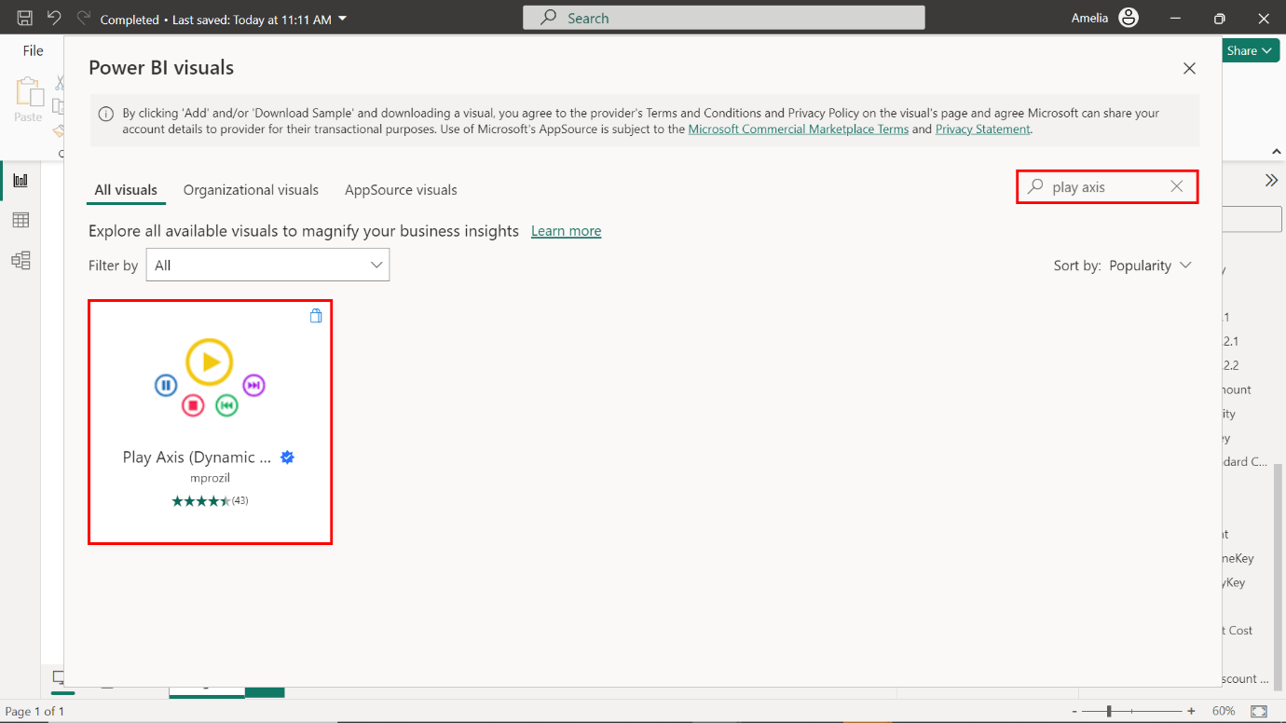

1. The details of the **Play Axis (Dynamic Slicer)** option are now displayed. Select the **Add** button on the left of the window to import this option and add it to your available visuals.

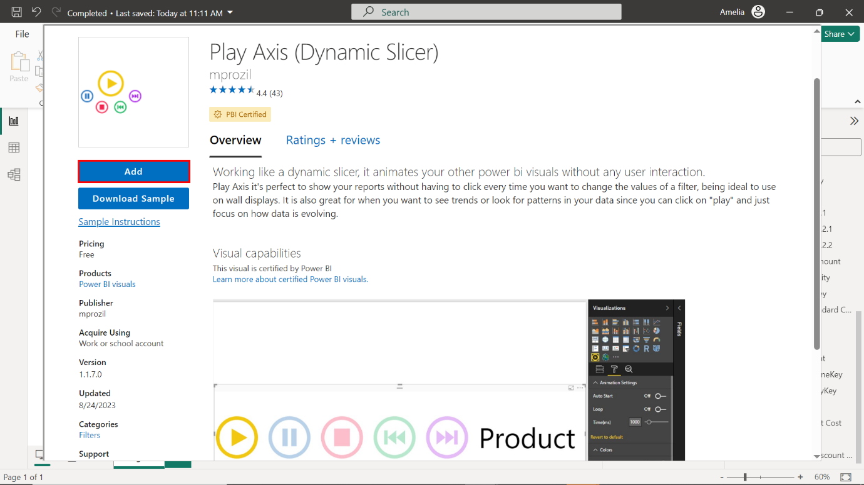

1. A confirmation message appears indicating that the visual was successfully imported.

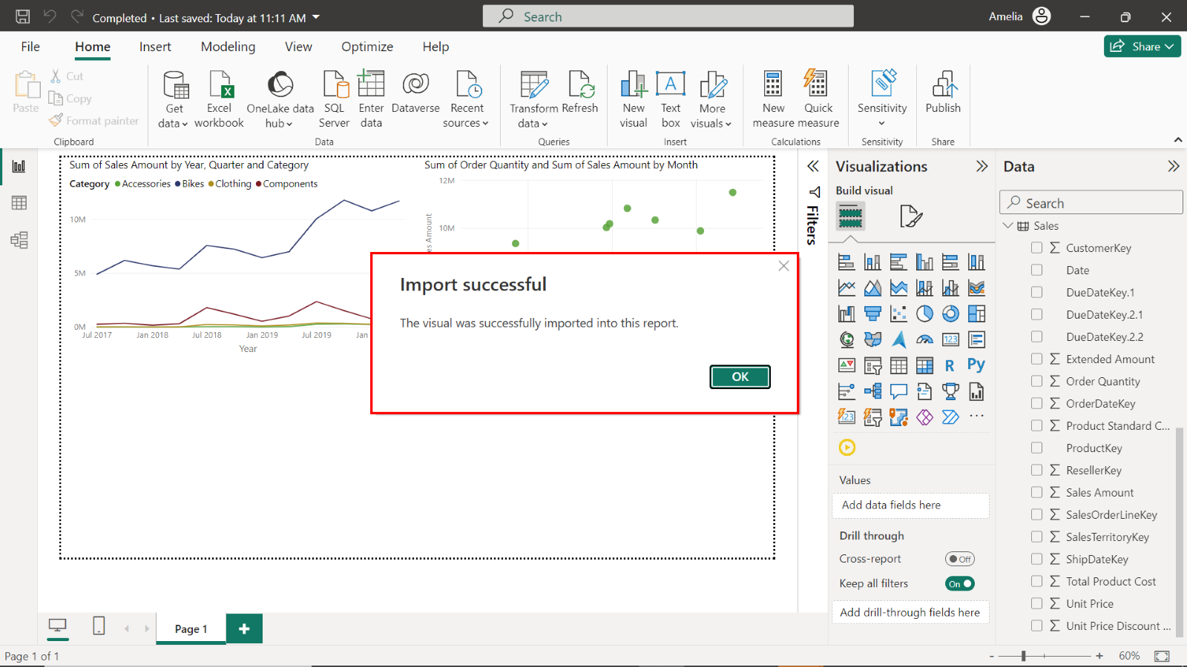

**Step 4: Resize and reposition the visual**

1. The **Visualizations** pane now contains a new icon for the **Play Axis** visual. Select this icon to add the **Play Axis** visual to the report page.

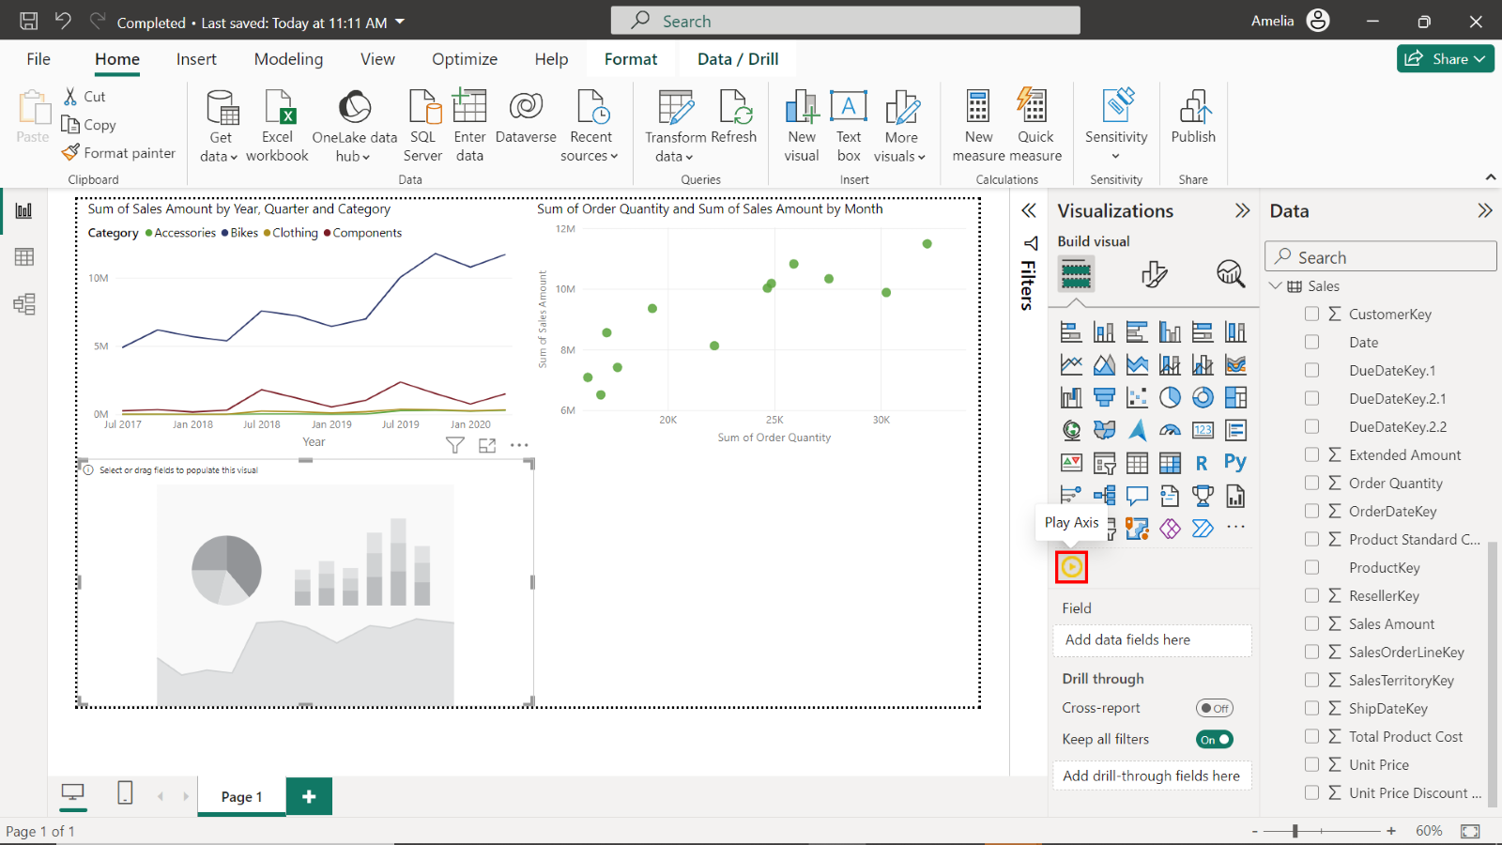

1. In the **Fields** pane, locate and drag the **Date** field from the **Date** table to the **Field** well of the **Play Axis** visual.
2. The **Play Axis** visual now contains a new set of controls. These are animation controls, which allow you to control how the **Play Axis** interacts with your data.

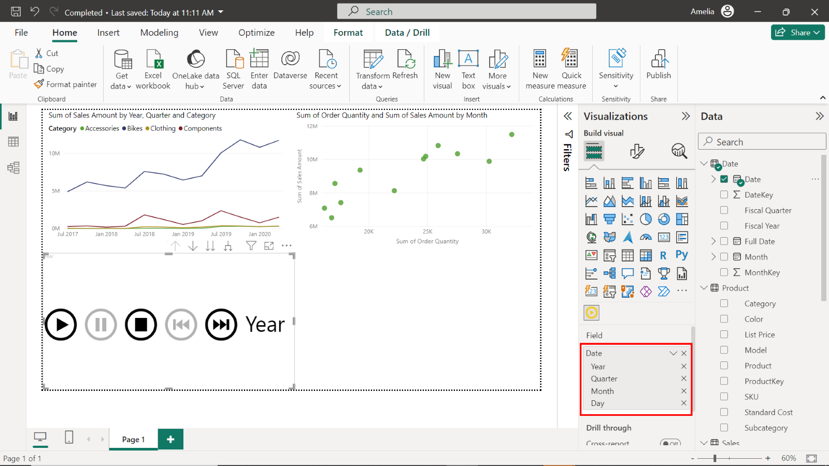

**Step 5: Customizing the Visual**

1. Select and drag the corners of the **Play Axis** visual to adjust its size. Select and drag its **Title bar** to reposition it on the page.

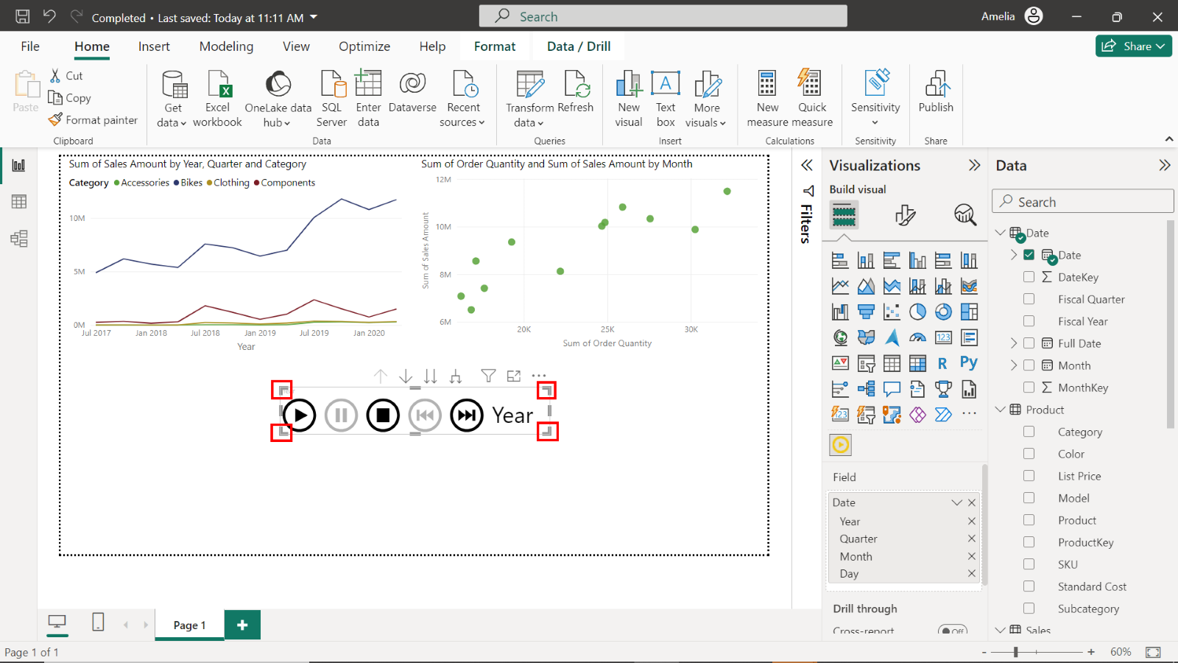

1. You can use the choices in **Animation Settings** to control how the animation behaves. **Animation Settings** is in the **Visual** tab of the **Format visual** pane on the right of the Power BI window. Here, you can adjust settings such as whether it starts automatically or loops continuously, and control the speed of the animation.

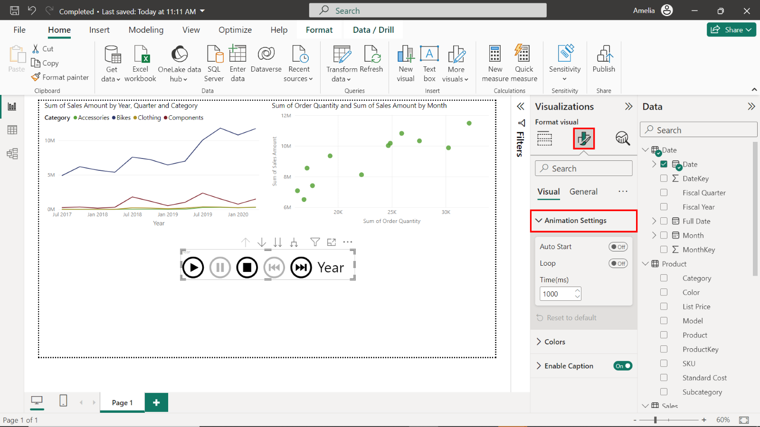

1. The **Format visual** pane also contains a **Colors** section. Here, you can make changes to the appearance of the **Play Axis** visual, such as adjusting the color of individual control buttons.

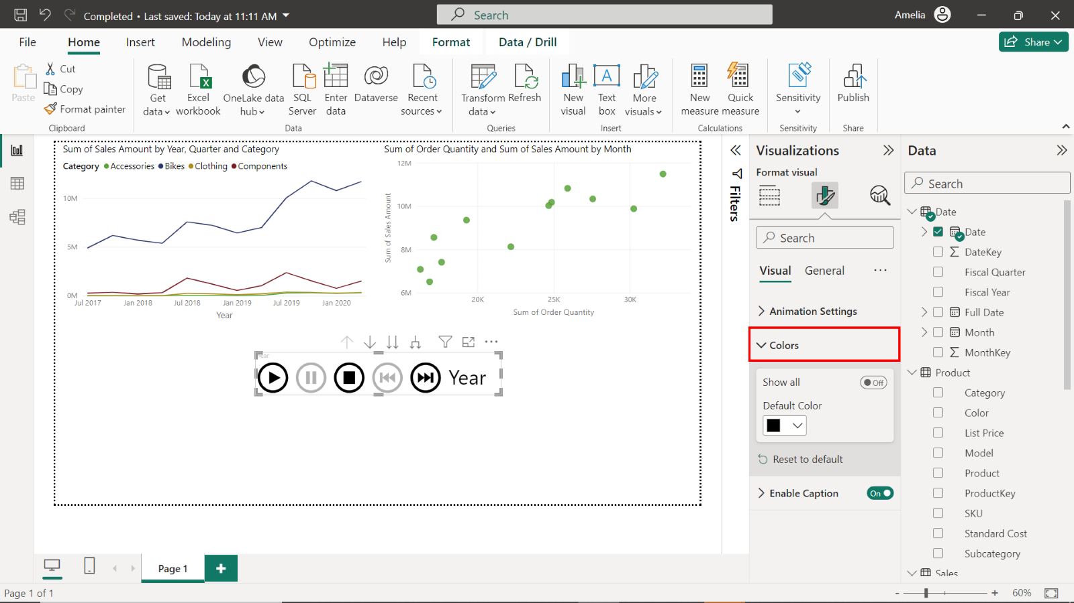

1. The final section in the **Format visual** pane, is titled **Enable Caption On**. This allows you to turn the caption next to the visual on or off and adjust its formatting, like font size and color.

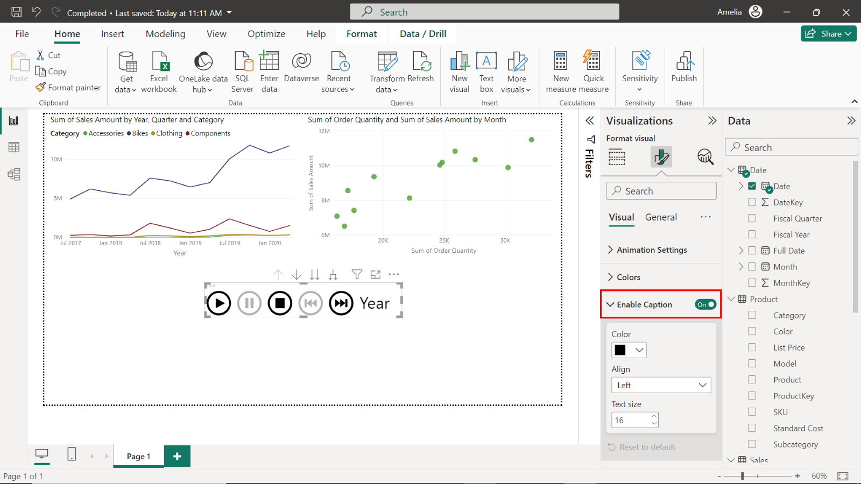

**Step 6: Using the Play Axis**

1. Select the **Play** button on the **Play Axis** visual. This will start the animation, demonstrating how your data changes over time.

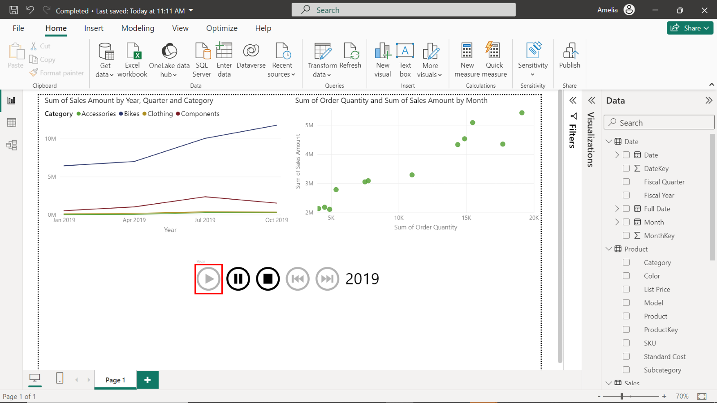

1. You can use the control buttons on the **Play Axis** to pause, restart, or step through the animation.

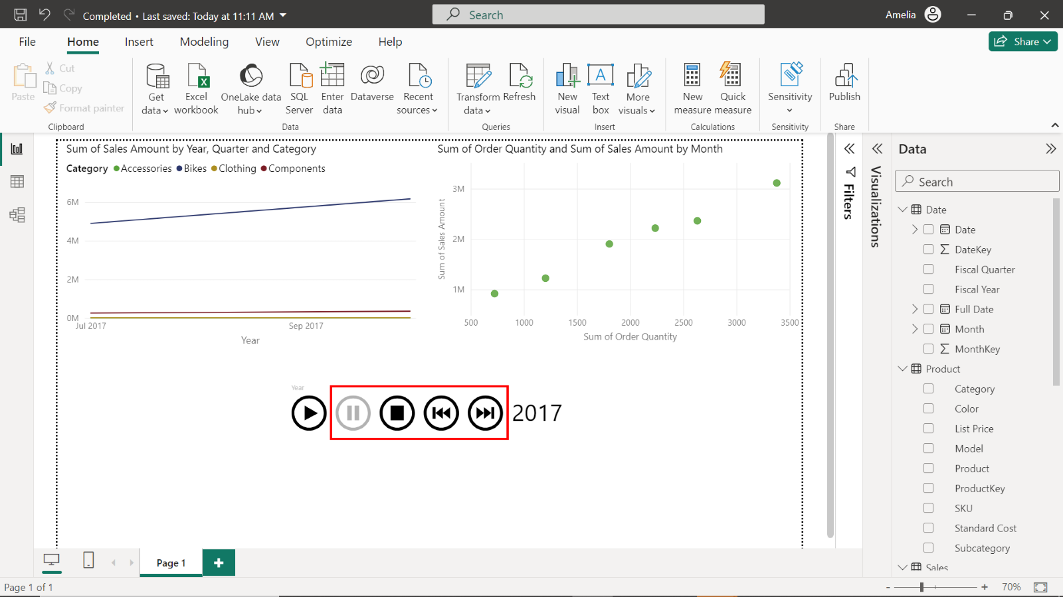

**Conclusion**

In this step-by-step guide, you learned how to integrate animation into your Power BI visuals to explore data evolution over time. By adding animation elements, such as **Play Axis**, you learned that you could enhance your reports and enable stakeholders to gain deeper insights into time-dependent data patterns. Whether you're analyzing quarterly sales trends, stock market fluctuations, or any time-based dataset, Power BI's time series capabilities and animation tools can transform your data analysis into a visually compelling and informative experience.